Rev. 08-01-17
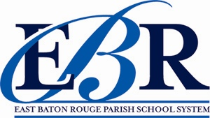
EAST BATON ROUGE Child Nutrition Program
PARISH SCHOOL SYSTEM 3000 N. Sherwood Forest Dr.
Baton Rouge, LA 70814

LACTOSE-FREE MILK REQUEST

DATE: ______________________________

SCHOOL: _________________________________________________

STUDENT: _________________________________________________

Dear Parent or Guardian,

Our cafeteria currently has a medical excuse on file for your child that states he/she is lactose intolerant and cannot drink regular fluid milk. We have lactose-free milk available as a substitute for regular milk. We cannot provide juice, soy milk or rice milk as a substitute. If you would like your child to drink lactose-free milk at school please fill out the request below and return it to the cafeteria manager.

Please return this completed form to the cafeteria manager

I am requesting that my child,__________________________________________________, who

attends, _______________________________________________ school, drink lactose-free milk

instead of regular milk as part of his/her school breakfast and lunch.

Parent or Guardian Signature:_______________________________________________________
Date

/tmp/in/input.doc

