9/9/2022
Dear Parent/ Guardian:

The health and safety of our students, families and staff are paramount. Like you, we are adapting to this challenging time for our city and school community. This letter requires no action on your part, its purpose is to inform you that a student/staff member in your child's class has been identified as being positive for COVID-19.

According to the Centers for Disease Control and Prevention,

For most people, the immediate risk of becoming seriously ill from the virus that causes COVID-19 is thought to be low. Older adults and people of any age who have serious underlying medical conditions may be at higher risk for more serious complications from COVID-19.

There are simple things you and your family can do to help keep yourselves and others healthy:
- Wash your hands often with soap and water for at least 20 seconds, especially after you have been in a public place, or after blowing your nose, coughing, or sneezing
- Avoid touching your eyes, nose, and mouth with unwashed hands
- Avoid close contact
- Cover your cough or sneeze with a tissue, then throw the tissue in the trash
- Clean and disinfect
- Monitor your health on a daily basis (refer to list of signs and symptoms below)

You can help stop COVID-19 by knowing the signs and symptoms:
- Fever (100.4 or greater) or chills
- Cough
- Shortness of breath or difficulty breathing
- Fatigue
- Muscle or body aches
- Headache
- New loss of taste or smell
- Sore throat
- Congestion or runny nose
- Nausea or vomiting
- Diarrhea

For more detailed information, see https://www.cdc.gov/coronavirus/2019-nCoV/index.html.
Please call your child’s physician or health care provider if you suspect your child may have the virus that causes COVID-19. Your child’s health care provider will make recommendations to you concerning a further course of action.

If you have any questions, please feel free to contact Health Centers in Schools at (225) 343-9505 or your child’s school.

Sincerely,
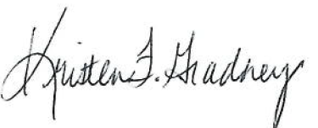
Stacey Dupre Kristen Gradney Jimeka Johnson
Chief Officer for Support OLOLCH Senior Director Principal
& Special Projects, EBRPSS Health Centers in Schools Highland Elementary

